SEE REGIONAL CONFERENCE OF ENTERPRISE EUROPE NETWORK
September 12-13, 2018
Montenegro
Hotel Verde Complex, Podgorica
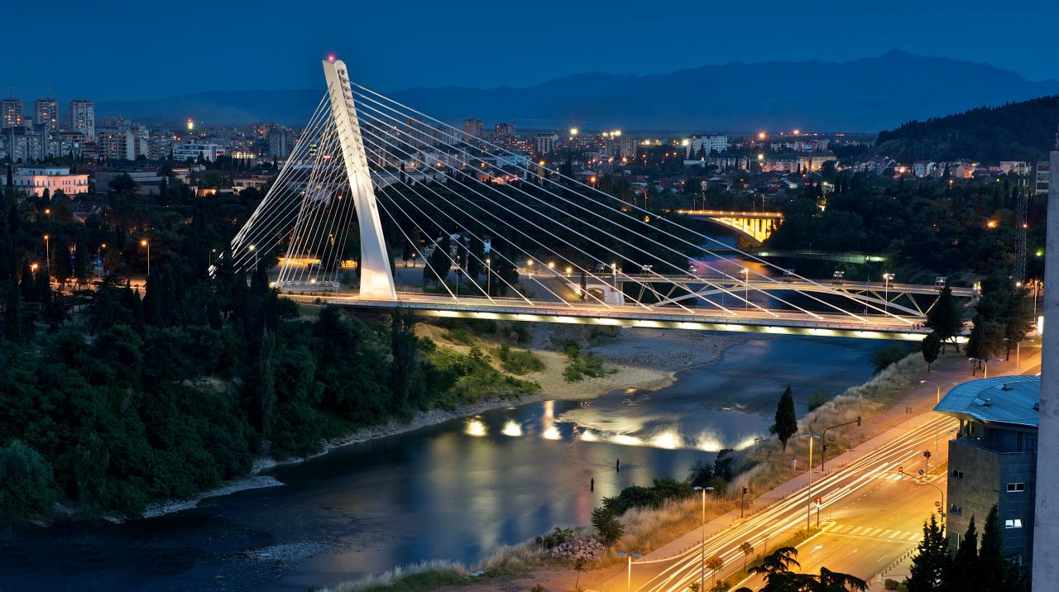
MontEENegro
- Ministry of Economy
- University of Montenegro – Faculty for Mechanical Engineering
- Chamber of Economy of Montenegro
- 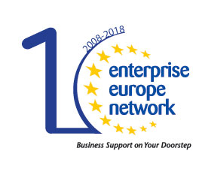Business Start Up Centre Bar

euroinfo.me

DRAFT AGENDA
Day 1. | 11. September
20:00 | Welcome reception, cocktail and unformal bilateral meetings with EEN colleagues
Day 2. | 12. September
08:30 – 09:00 | Registration of participants
 | Welcome and opening remarks
09:00 – 10:00 | - Ljiljana Belada, EEN Montenegro coordinator  - Dragica Sekulić, Minister of Economy of Montenegro  - Ivan Saveljić, Vice President of Chamber of Economy of Montenegro  - Igor Vušanović, Dean of the Faculty for Mechanical Engineering at the University of Montenegro  - Ivana Tomašević, Director of the Business Start Up Centre Bar
 | Network vision, performance and achievements
10:00 – 10:45 | - István Németh, European Commission, DG for Internal Market, Industry, Entrepreneurship and SMEs  - Natalia Martinez Paramo, European Commission, EASME, Head of Unit COSME
10:45 – 11:15 | Coffee break
 | Montenegro economic overview
11:15 – 11:30 | Ljiljana Belada, Ministry of Economy, Head of Unit
 | Panel session - Best practices – MontEENegro entrepreneurs
11:30 – 13:00 | - Nenad Novović, Amplitudo doo  - Mirjana Babić, Olivmont doo  - Uroš Bulatović, Union of Young Entrepreneurs  - Elma Hot, Bee&Me doo
13:00 - 14:00 | Lunch break
 | Best practices from SEE Region
14:30 - 15:45 | - “Voogle conference”, Emilija Stručić, Croatia  - “Access to finance: Assistance in applying for a loan”, Aida Džamalija Duran, BIH, Federation of Bosnia and Herzegovina  - “Client support: Establishment of partnerships and improvement of innovation management capacities”, Mladen Kostić, BIH, Federation of Bosnia and Herzegovina  - “Enhancing Innovation Management Capacities: how to select the innovative SMEs?”, Beti Kostadinovska Dimitrovska, FYROM  - “The best practice of collaboration between universities and industrial SMEs (with support of the EEN) ”, Bojan Ćudić, BIH, Republic of Srpska  - “Quality support and improvement of competitiveness ”, Olivera Radić, BIH, Republic of Srpska
15:45 – 16:00 | Coffee break
 | Best practices from SEE Region
16:00 - 17:00 | - “Belgrade Food Show”, Marko Kovačević, Serbia  - “Smart specialization: challenges and opportunities for SMEs in the Western Balkans and the role of EEN in capacity building and SME support in implementing the S3 priorities”, prof. Đuro Kutlača, Serbia  - “Help and advise on company transfer”, Peter Ekart and Vladimir Rudl, Slovenia  - “Ethics and quality”, Zdravko Krivokapić, Montenegro
20:30 | Social dinner

Day 3. | 13. September
09:30 - 10:00 | Welcome coffee
 | Training and networking session
10:00 – 13:00 | Workshop - Enhancing the vision of the Network, cooperation goals setting, networking and management skills
13:00 - 14:00 | Lunch break
 | Conference closing
14:00 – 15:00 | Closing remarks
 | Optional
15:00 | Visit tour to Cetinje, Royal Capital of Montenegro

